DR. AMBEDKAR COLLEGE, DEEKSHA BHOOMI, NAGPUR
REPORT
2017-18
ANTI RAGGING CELL OF THE COLLEGE INTRODUCED BUDDY SYSTEM FOR STUDENT’S SAFETY: 10/09//2017
Students i.e. seniors & juniors of Dr. Ambedkar College Deeksha Bhoomi, joined hands for ragging free campus. DACN strongly believe that, college is the centre of learning where minds are trained. Fresher’s come to the college with an idea that it’s a beautiful world where they will be welcomed and will be learning many good things. However, terrible things also may happen here. To have check on this we had organised different programmes under the banner of Anti Ragging cell. But for the first time we have introduced a buddy system in our college, where senior students acted as mentors for fresher’s. Here the senior guided the fresher’s on different legal provisions as well as they narrated through different stories, why these practices need to be banned. Even through drama they depicted deterrent effects of ragging on human mind and thus gave a strong message to stay away from these evil practices. At the same time some seniors volunteered to be mentors and interacted with freshers and shared their experiences. It was really a very unique and meaningful programme, which was completely organised and planned by the students for the students. The programme was conducted under the able guidance of Dr. Sandhya Kalamdhad, Co-ordinator of Anti- Ragging Cell. Vote of thanks was proposed by Dr. Dhanashree Borikar, Faculty and Member of Anti Ragging Cell.
Mrs. Vaishali Sukhdeve, Ms. Shazia Bari, Mr. Sachin Tripathi & Mr. Rahul Dhoble along with volunteers from department of Law worked hard for the accomplishment of the programme. 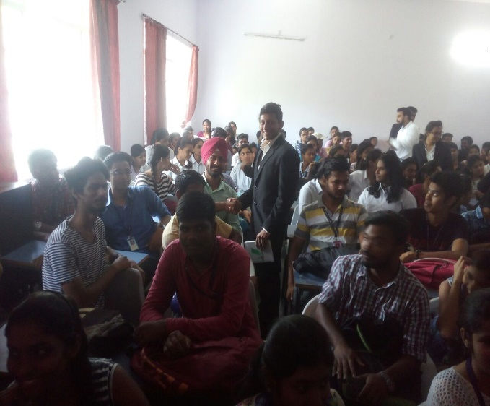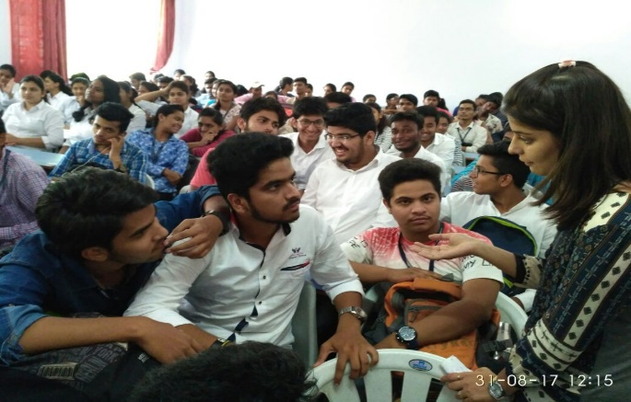
Seniors acting as mentors for the juniors

- 7th Sep. 2017 : Poster Making Competition on Ragging
Poster making competition was hold to make awareness amongst the students of DACN family in respect of ragging. Ragging is a subject which concerns everybody and therefore sensitisation of this subject especially amongst the students is very much essential. Keeping that in mind we organised this competition and we get astonishing response from the students of all departments of college. On the day of panel Discussion the results were declared and prizes were distributed at the hands of Panellists.
